PortSwigger Web Security Academy — Proof of Concept

SQL Injection Lab 5

SQL injection UNION attack, retrieving data from other tables
Category | SQL Injection
Lab | Lab 5
Completed By | Security Researcher
Platform | PortSwigger Web Security Academy

Lab Objective
Retrieve username and password from the users table using UNION attack.

Step-by-Step Exploitation
- Open Burp Suite and configure browser proxy.
- Navigate to the lab URL and identify the vulnerable functionality.
- Intercept the relevant HTTP request in Burp Proxy.
- Send the request to Burp Repeater for analysis.
- Craft and inject the appropriate payload into the vulnerable parameter.
- Forward the modified request and observe the response.
- Verify the exploit was successful as shown in the screenshots below.

Screenshots & Evidence
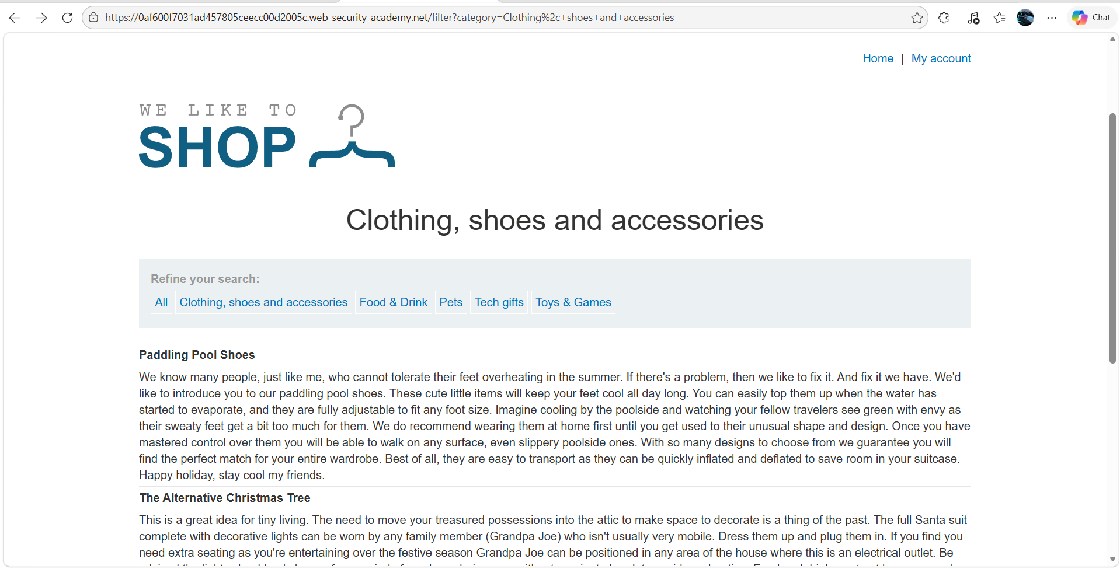
Figure 1: 1st Page Lab 5 Sql
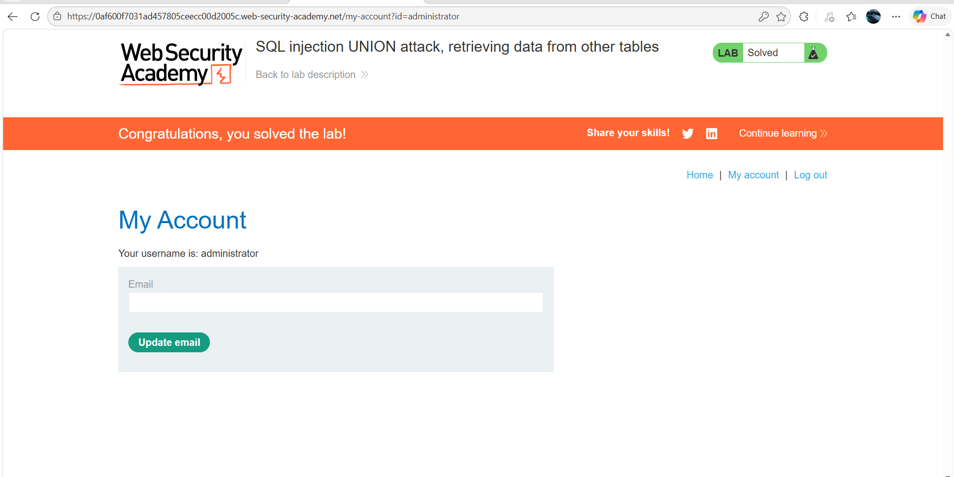
Figure 2: Lab Sloved
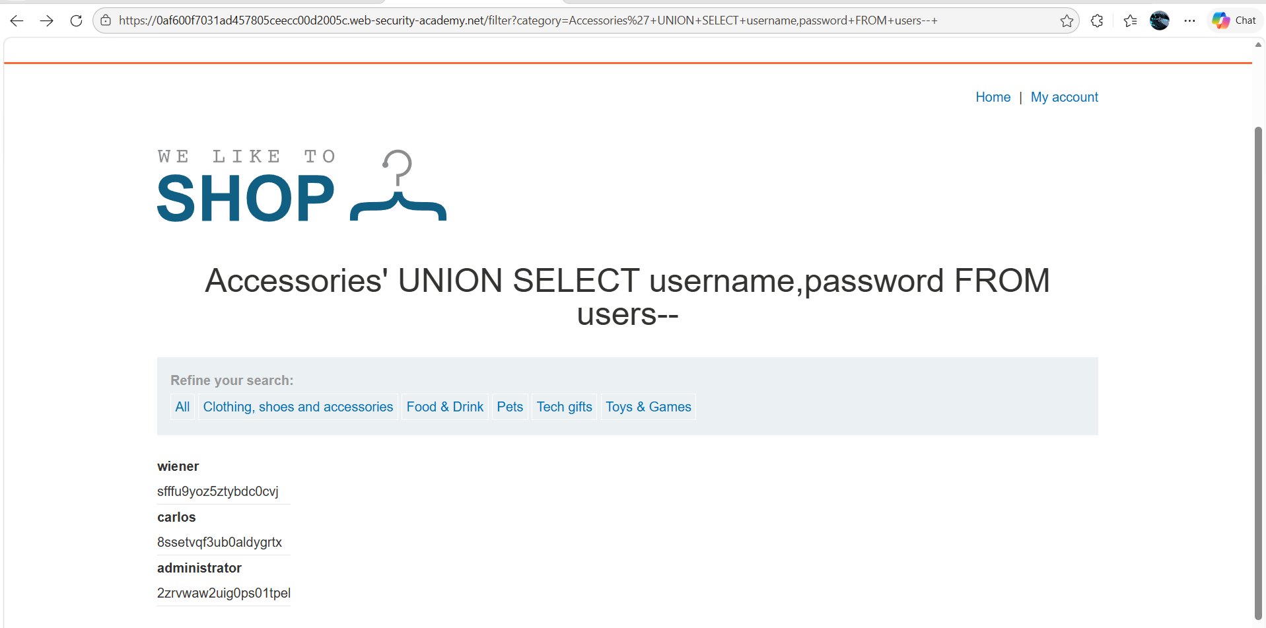
Figure 3: Modify The Url Request And You Get The Admin Password

Lab Status: SOLVED

